**Bone Conduction Military Helmet**

**ME423 Machine Design Autumn 2020**

**Group 8**

* Atharv Kotwal (170110068)
* Manan Tayal (170100005)
* Amey Gohil (170100019)
* Milind Chandnani (170110001)
* Bavish K (170040106)

Human Auditory nerve, which takes audio signals from cochlea to the brain, is connected to the Organ of Corti in cochlea which is located on the basilar membrane. Therefore the displacement at the basilar membrane directly affects the sound we hear. This basilar membrane can be stimulated in 2 ways:

* Air Conduction: Normal Hearing through eardrum vibrations transmitted via middle ear bones (malleus, incus, and stapes).
* Bone Conduction: Vibrations transmitted through the skull.

The way we hear our own voice even after closing our ears is through bone conduction. Bone conduction also occurs in our Normal Hearing state through the skull but the stimulation on the basilar membrane is extremely low below 100 dB. Above 100 dB we can hear the sound even if we close our ears using ear plugs which is due to bone conduction.

**Need**

* The Soldiers in the war need to keep a walky talky in their hands in order to communicate with the control room and with each other. Also, if they wear a headphone over their ears they can only focus on talking and may miss the noise of some bullet/ bomb blast.
* So they need to talk to each other while knowing the war environment. And therefore they might want to use a bone conduction headphone with a mic to hear the sounds from the environment and at the same time talk to each other.
* Moreover since above 100 dB we can hear the sound even if we close our ears using ear plugs which is due to bone conduction, we can analyse the insulation through bone conduction.

**Working Principles**

In this report, bone conduction phenomenon is studied and a bone conduction helmet is designed. The major use of this helmet is for military purposes where the soldier needs to hear the surrounding noises as well as clearly hear the commands from his officer. 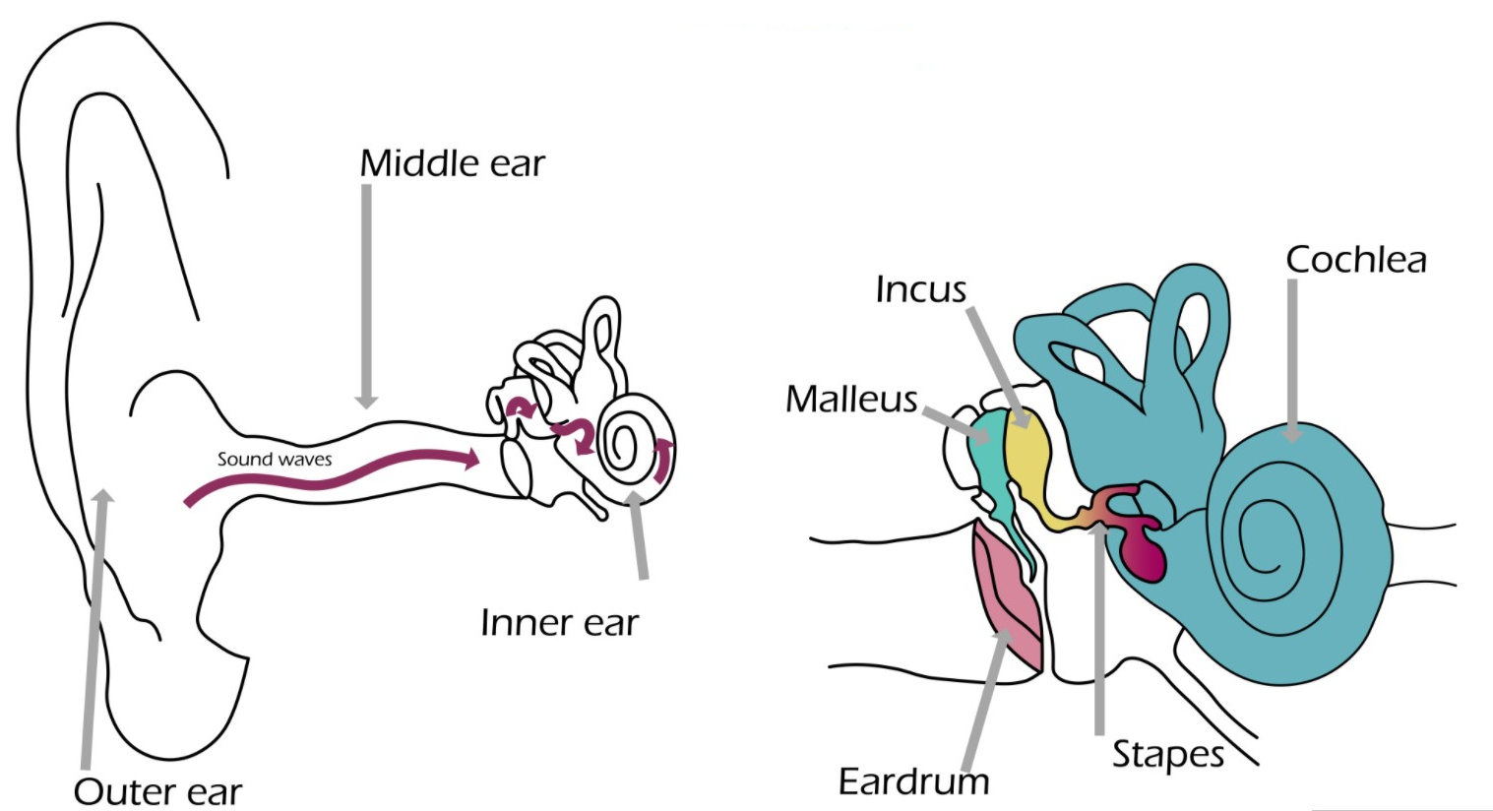

The idea is to give commands using the bone conduction signal whereas the outside noises can be heard using normal air conduction hearing.

**Modelling**

Bone conduction happens through the skull, hence, ideally simulations should be performed on the whole skull. But to ease the complexity of the model, the skull was modelled as a sphere and some features like cochlear bones, ear canal and a flat surface to give vibrations were added. In the approximated skull 2 large holes are given to approximate many small openings in the skull. The images below show the approximated mesh as well as actual skull.

**Cochlear Bones** are highlighted in both. At the end of these bones a basilar membrane is presented.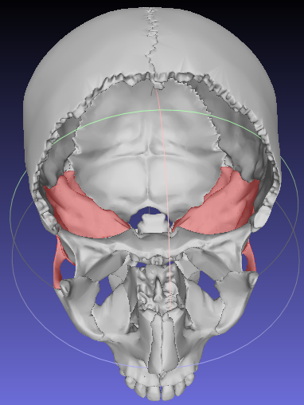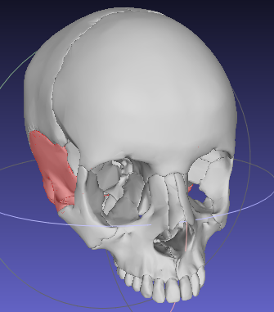

**Actual Skull** :

**Material Properties of Bone:**

|  |  |
| --- | --- |
| Young’s Modulus E | 7300 MPa |
| Density | 870 kg/m3 |
| Poisson Ratio | 0.3 |

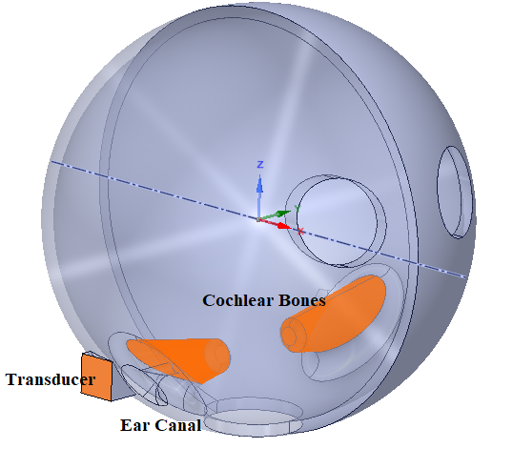

**Approximated Model**: Same material

|  |  |
| --- | --- |
| Skull Thickness | 7.5 mm |
| Skull Diameter | 25 cm |
| Cochlear bone length | 7 cm |
| Cochlear bone diameter | 4 cm |
| Ear Canal Length | 3 cm |
| Ear Canal diameter | 8 mm |
| Transducer Area | 2.5 * 2.5 cm2 |

**Model Validation**

Model is validated by giving a point load of 1 N at one end (where the transducer is highlighted in Figure above). The mechanical impedance at the input was compared with the literature.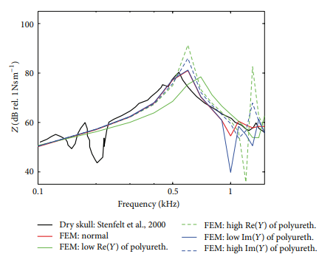

Literature:

Frequency Range: 100 - 1500 Hz

Model:

Frequency Range: 100 - 5000 Hz

* Trend is similar as given in literature.
* The peak occurs at 800 Hz compared to 600 Hz in literature.
* Mechanical Impedance of the model is higher than the actual skull given in literature because a uniform thickness sphere is considered everywhere which increases the stiffness whereas the actual skull has many openings and variation in thickness.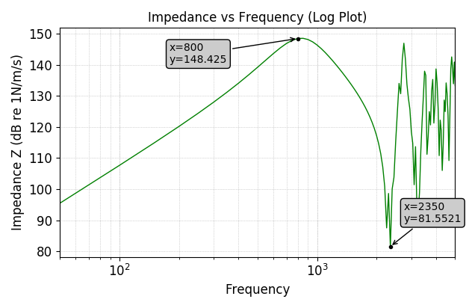

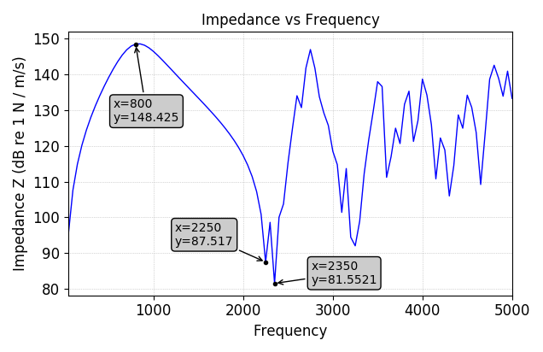

**Frequency Range Selection**

Now, a dynamic load is given over the whole area of transducer (2.5cm * 2.5cm) and Frequency Response is obtained for displacement at the end of cochlear bone.

**Frequency Range**: 50 - 5000 Hz

**Load**: 0.01 N

**Transducer Area**: 2.5 cm * 2.5 cm = 6.25 * 10 - 4 cm2

**Pressure on Transducer**: 16 Pa

**Boundary Conditions**:

* Fixed Support where skull connects the neck
* Specific Force on Transducer Area on both sides

**Probe:** Measure displacement at theend of cochlear bone which connects to basilar membrane

**Software**: Ansys Harmonic Response

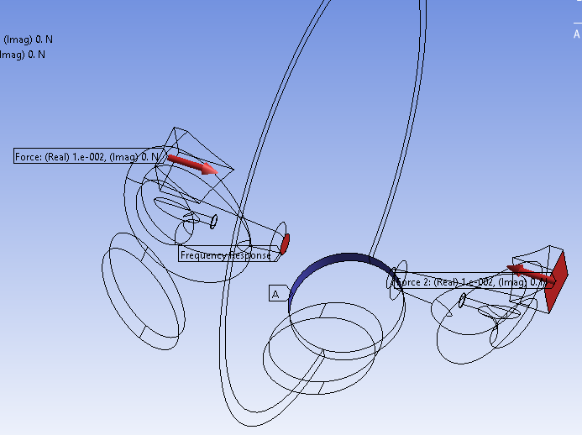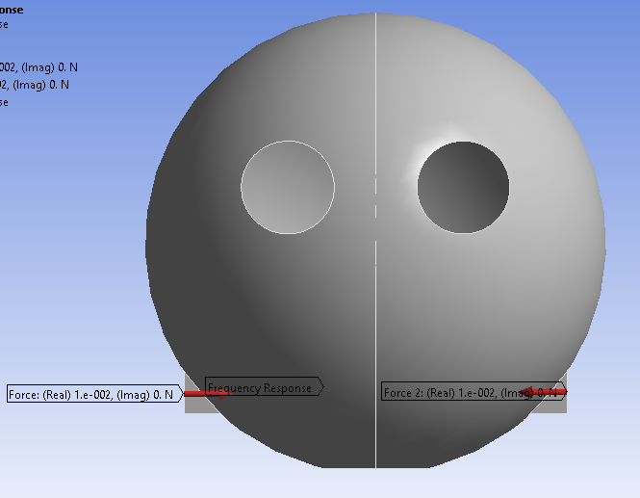

**Results**

Mechanical Impedance vs Frequency:

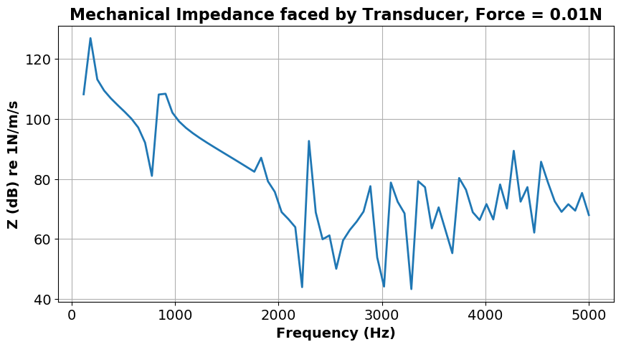

Frequency Response of Displacement at Basilar membrane:

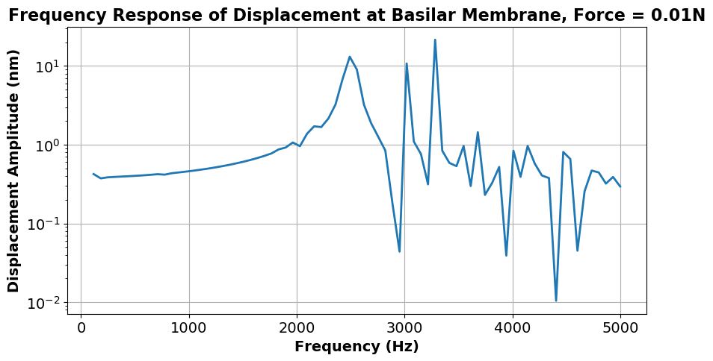

* The low frequency region ( <1500 Hz ) is not possible because of transducer limitations. Transducers of small sizes work best for higher frequencies.
* There is a peak at 2500 Hz where displacement is ~ 10 nm which is high for the basilar membrane. Also between 2300 - 3500 Hz, the region is highly non-linear with many peaks and troughs which is not good.
* Frequencies after 4000 Hz have smaller displacements.
* The **best frequency range** for our purpose is therefore **1800 - 2200 Hz** i.e. we can tune the transducer around 2000 Hz Frequency.

**Clamping Force Selection**

The same model above is iterated a few times to get the best possible displacements at the basilar membrane.

Average displacement in frequency range 1800 - 2200 Hz:

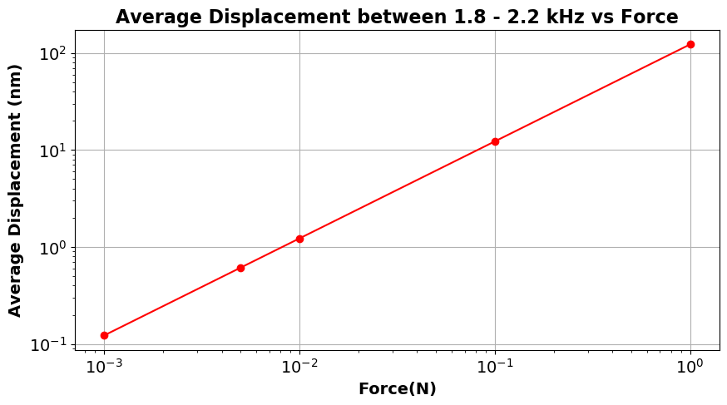

* Plot is fairly linear. Best Fit Equation:

**log(disp in nm) = log(Force) + 2.089**

* Displacement at the basilar membrane should be around 0.6 nm.
* Hence, the force amplitude to be applied on the skull should be **~** **0.005 N.**
* Using the above equation force can be calculated for any displacement. Displacement at the basilar membrane for a particular frequency is directly proportional to the loudness of sound we hear.

Force amplitude on skull = 0.005 N

Pressure Amplitude ∆p = Force / Area = 0.005 / (2.5 * 2.5 cm2 ) = 8 Pa

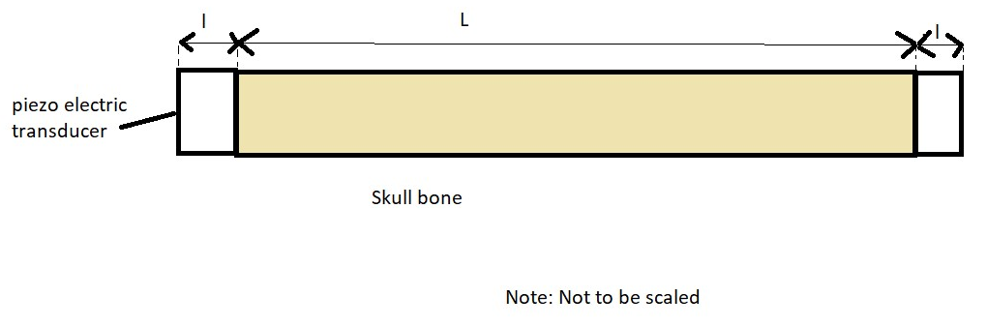

When a unit volt is passed through piezoelectric material it expands by ∆l

Therefore, εpiezo=∆l/l = d*E =d*V/l (where d is piezoelectric coefficient)

=2*10-12 * (1/0.5*10-3)

=4*10-9

If we consider the skull bone to be stiff enough,

∆p/p =εpiezo / ε

= 4*10-9/1.6*10-6 (Allowable strain corresponding to the bearable stress)

=0.0025

In our case ∆p = 8 Pa

therefore, p = 8/0.0025Pa = **3200 Pa**

**Clamping Force =** p * A = 3200 * (2.5 * 2.5 cm2) = **2 N.**

Clamping Force can be slightly varied as per user requirement using the screw. Force on skull (= 0.0025 * Clamping Force ), which is a function of Clamping Force, governs the displacement of the membrane.

**Acoustic Insulation in Helmet:**

Using the force applied through the transducer, equivalent Sound Pressure Level can be calculated using the following:

SPL(dB) = 20 * log ( P / Pref ) , where, Pref = 20 * 10-6 Pa

P = F / A , A = 2.5 * 2.5 cm2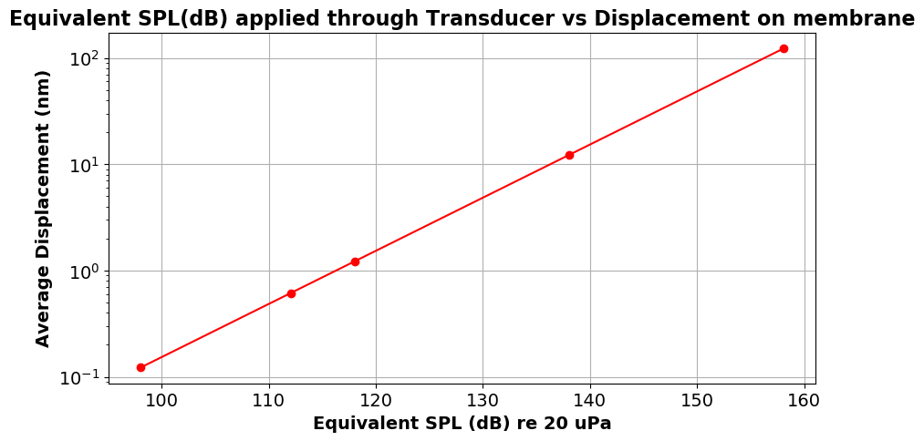

* This plot shows that if the external sound is above 100 dB, then it can be perceived by cochlea through bone conduction.
* This means that in a harsh acoustic environment (like navy aircraft carriers or sound of guns which goes upto 140 dB) with high noise levels **even if the person wears ear plugs, he may end up damaging his basilar membrane because sound vibrations will travel through bone conduction**.
* Hence, a helmet is required which will attenuate these vibrations from entering the skull. Special materials like foam are inserted in the helmet for these purposes.

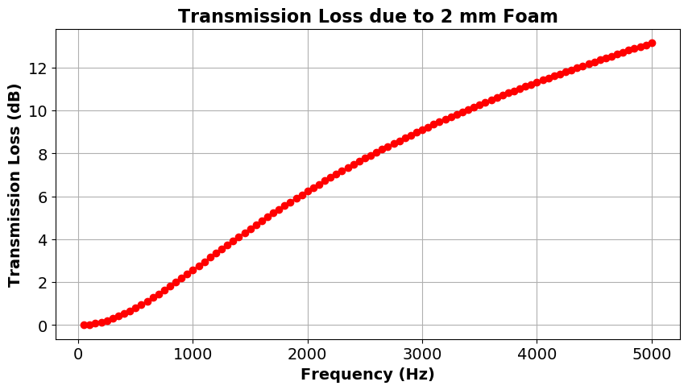

The bullets and bomb blasts generally create a noise at 1000Hz of frequency.

Sound to attenuate = 40 dB

Therefore, we need at least (40 / 2.5)*2mm **= 32mm of foam** to attenuate this noise.

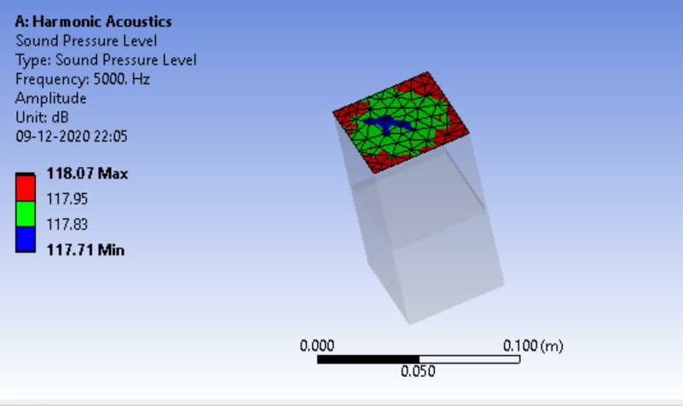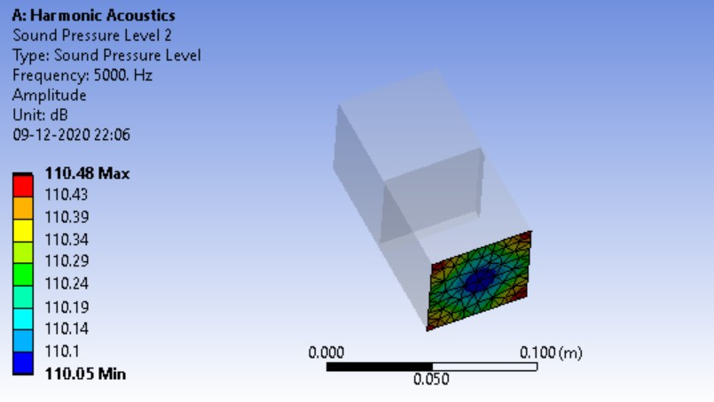

**Electronics Circuit**

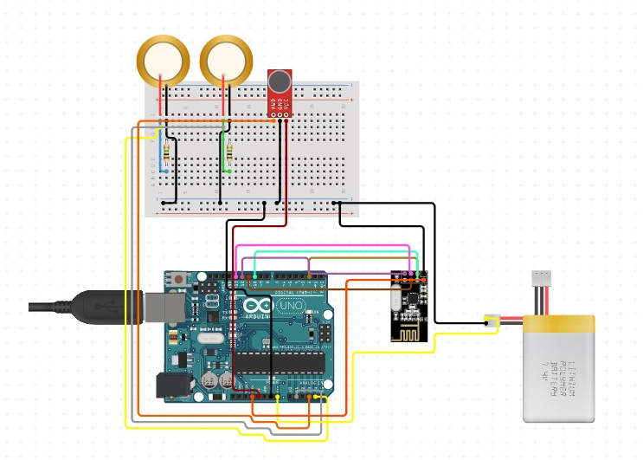

The electronics part contains Arduino (microcontroller), NRF24L01 - 2.4G Wireless Transceiver Module to receive and transmit the signals back and forth to the soldier, Piezo Transducer to conduct the signals from circuit to the cochlea via bone, Lithium Polymer Battery to power up the circuit and the microphone to communicate.

**Material Analysis**

Firstly we will analyse the impact analysis (if the thickness of a certain material can prevent the bullet from piercing the material).

Considering the following conditions we obtain the table below:

Bullet: Lead 20 mm Factor of Safety = 2 Velocity of the Bullet: 500 m/s

|  |  |  |  |  |
| --- | --- | --- | --- | --- |
| Plate Material | Thickness | Remarks | Thickness with FOS | Mass (kg) |
| Steel | 0.5 mm | Failed | 1mm | 0.8 |
| Kevlar | 0.5 mm | Failed | 1mm | 0.144 |
| UHMWP | 0.5 mm | Failed | 1mm | 0.097 |
| Steel | 3 mm | Passed | 6mm | 4.8 |
| **Kevlar** | **3 mm** | **Passed** | **6mm** | **0.864** |
| UHMWP | 3 mm | Failed | 6mm | 0.582 |
| UHMWP | 4 mm | Failed | 8mm | 0.776 |
| UHMWP | 8 mm | Passed | 16mm | 1.552 |

Following are the gifs of the impact on the flat plate

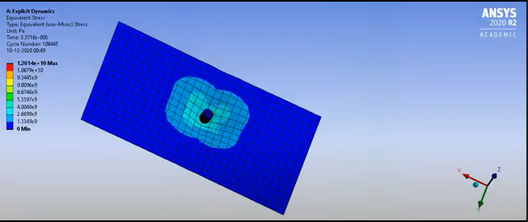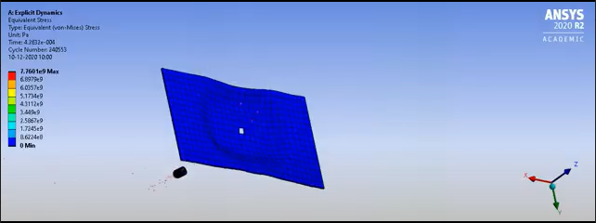

Kevlar 3mm UHMWP 3mm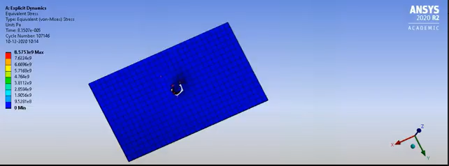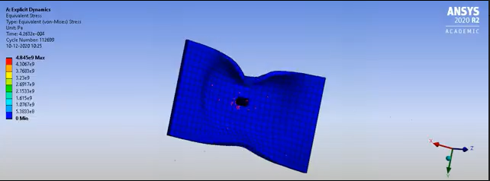

UHMWP 4mm UHMWP 8mm

Next we need to analyse the impact energy of the cases in which the bullet is not penetrating:

Kevlar 3mm Plate

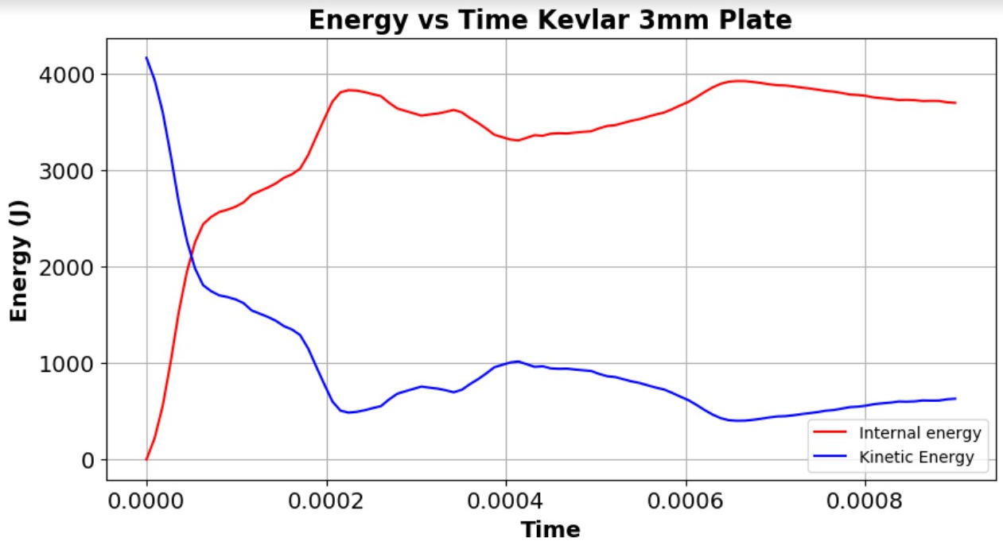

Max impact (internal) energy is around 3900J

Therefore, impact strength is impact (internal) energy/ thickness= 3900/3 J/mm

= 1.3 MJ/m

UHMWP 8mm Plate

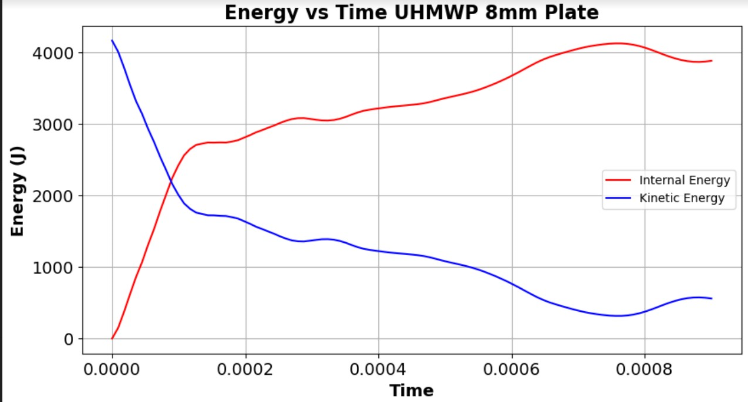

Max impact (internal) energy is around 4100J

Therefore, impact strength is impact (internal) energy/ thickness = 4100/8 J/mm

= 0.512 MJ/m

**Manufacturing drawings**

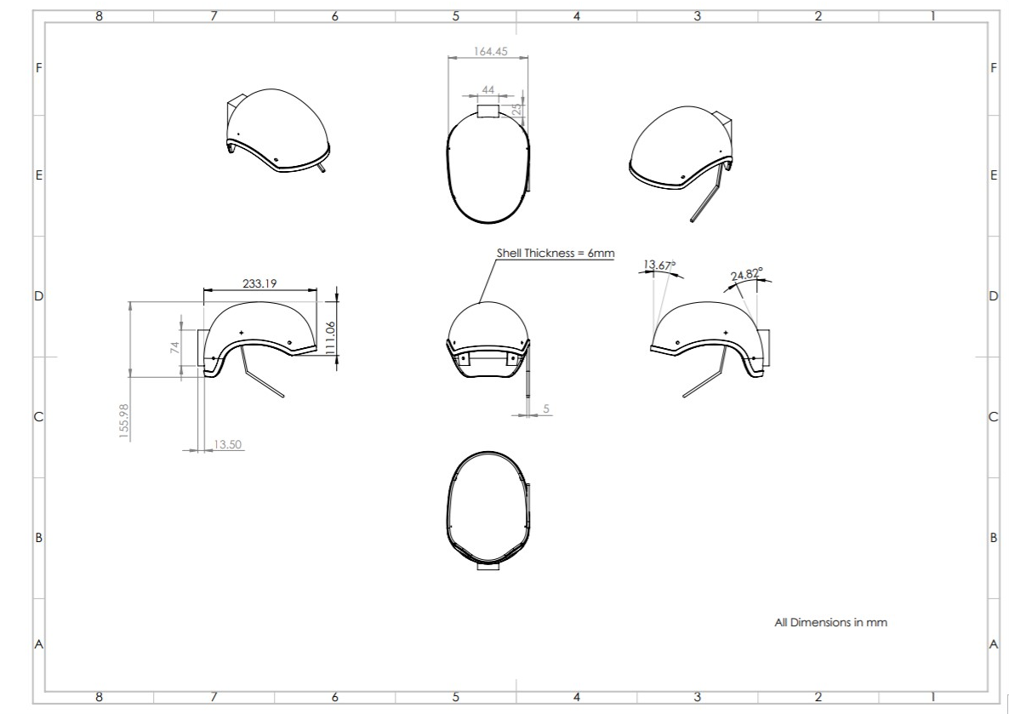

**CAD Models**

**Helmet**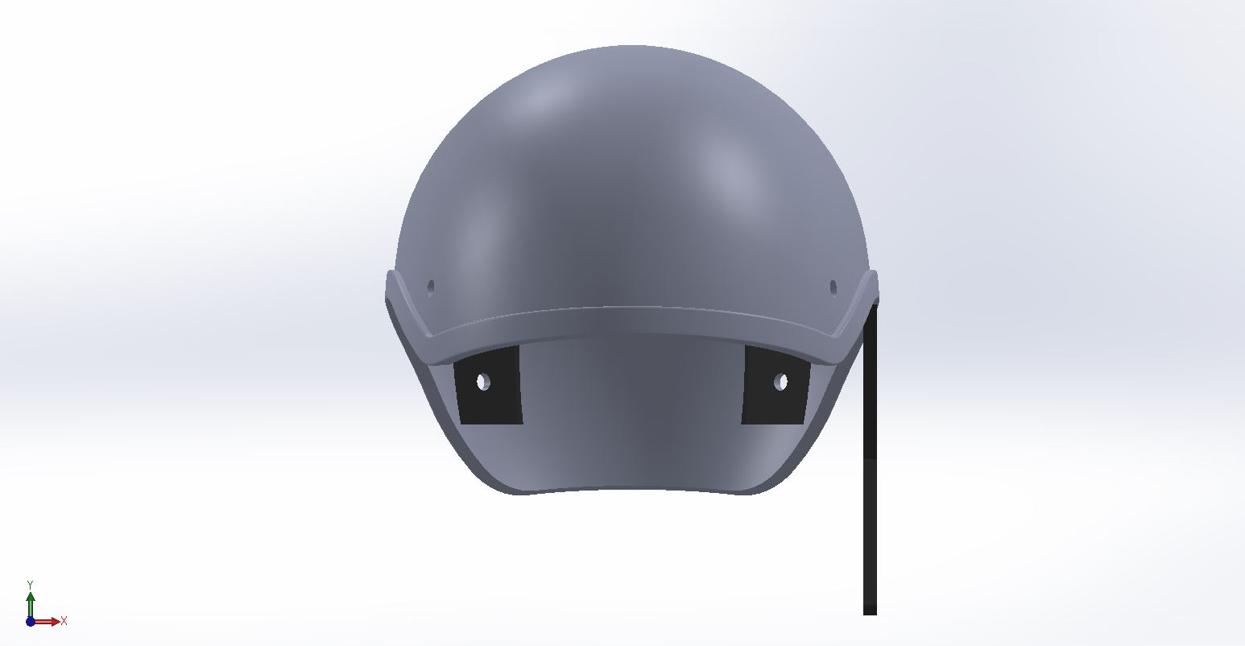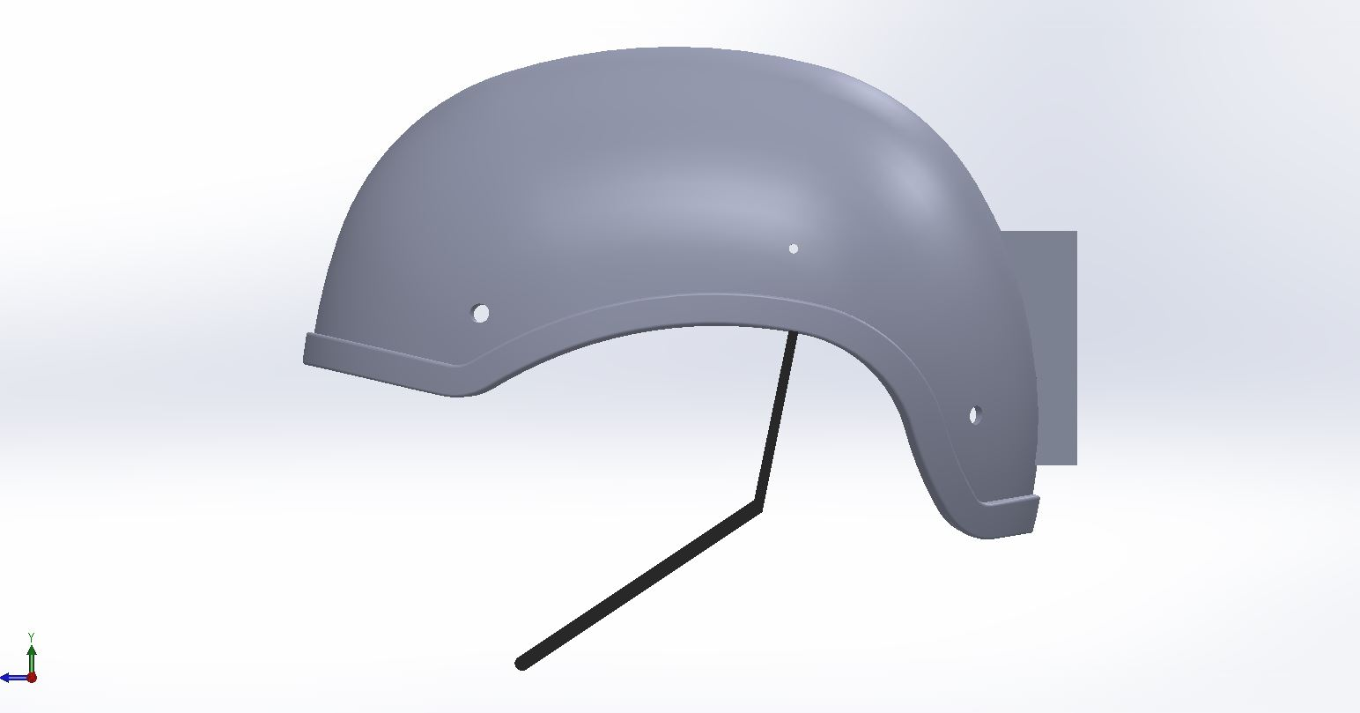

A basic helmet model is made using SolidWorks. It has a box compartment to store the electrical circuit on the back side. For placing the transducer, there are two slots on the inner surface at the back of the helmet. A metal strip is added on the side to account for the mike for communication purposes.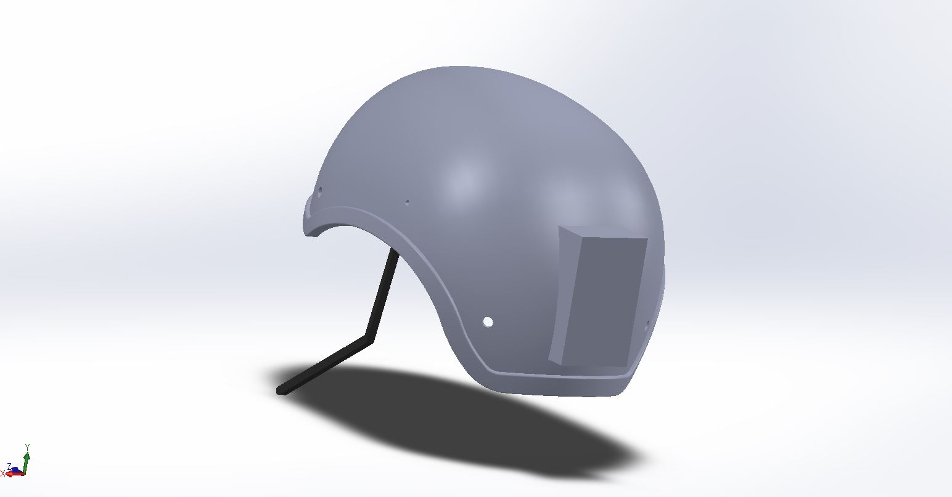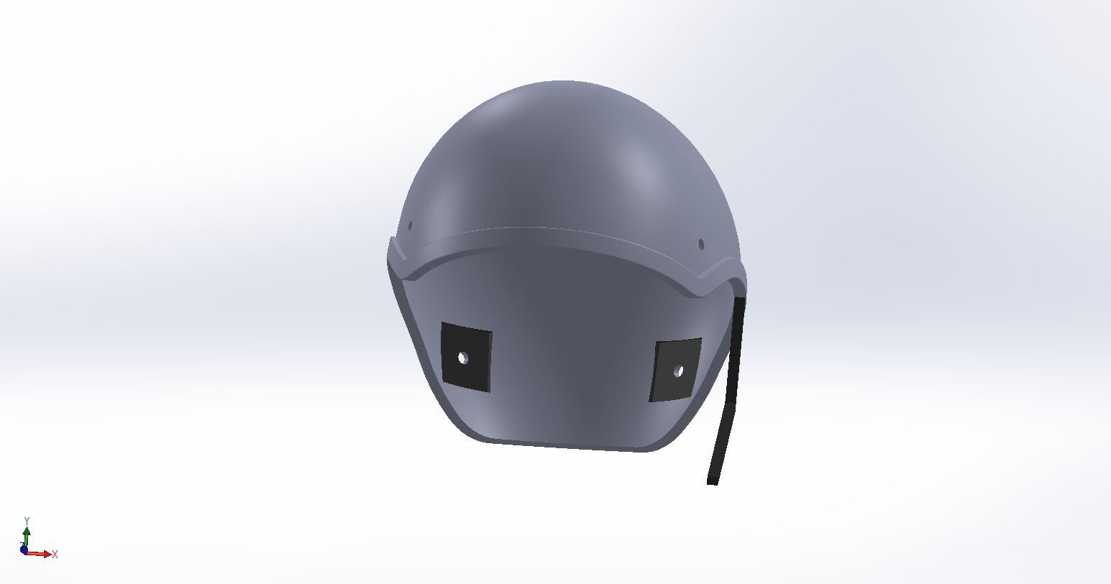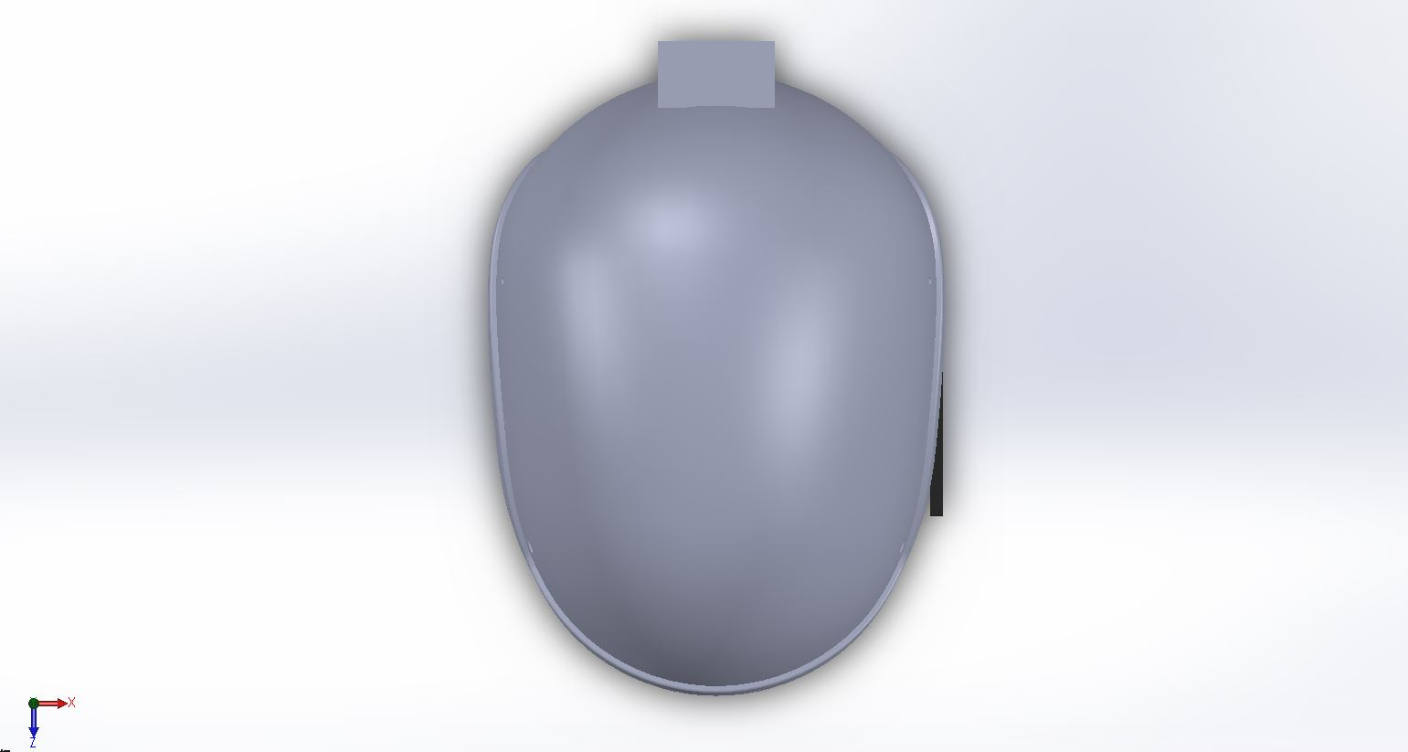

**Spring Plunger**

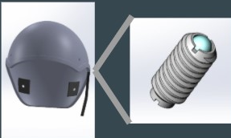

A spring plunger is also added to make fine adjustments

For Fine tuning of contact force mentioned above, We want 0.02N change in one pitch (pitch 1.25mm)

Stiffness of spring is 0.02N/1.25mm = **16N/m**.

**Bill of the components**

|  |  |  |
| --- | --- | --- |
| **Name of component** | **Quantity** | **Price (in INR)** |
| Arduino | 1 | 500 |
| NRF24L01 - 2.4G Wireless Transceiver Module | 1 | 100 |
| Piezo Transducer | 2 | 60 |
| 1.0M Ohm Resistor | 2 | 2 |
| Lithium Polymer Battery - 7.4v | 1 | 1000 |
| Microphone | 1 | 250 |
| Wires |  | 50 |
| Perforated Board | 2 | 80 |
| Kevlar | 1kg | 600 |
| Foam |  | 1000 |
| Spring Plunger | 2 | 200 |
| Miscellaneous |  | 500 |
| Total |  | **4042** |

**Final Design Specifications**

Helmet Thickness - 6mm Helmet Mass Volume - 582.93cm3

Material - Kevlar Mass of Helmet - 864 gm

Spring Plunger pitch - 1.25mm

Stiffness = 16N/m

Transducer Area - 2.5 cm * 2.5 cm3

Clamping Force - 2N

Frequency Range - 1800 - 2200 Hz

**Summary and Highlights of the project**

Final Product is a Helmet for Military Purposes with these features:

* Bone Conduction transmission of sound for clear hearing of commands
* Acoustically Insulating Foam for high noise levels.
* Other features of helmet like bullet proofing etc.

The main aim of the project was to incorporate bone conduction transmission in helmets and to prevent the external large sounds to enter the head and thereby the cochlea along with the traditional use to protect the head from bullets.

**Contribution from each member**

|  |  |  |
| --- | --- | --- |
| Atharv Kotwal | 20% | Acoustic Analysis: Frequency and Clamping Force Selection |
| Manan Tayal | 20% | Electronic Circuit and Acoustic Insulation |
| Amey Gohil | 20% | CAD Modelling |
| Milind  Chandnani | 20% | Material Selection using Ansys Impact Analysis and Simulations |
| Bavish K | 20% | CAD Modelling , Acoustic Model Approximation |

**Effect of External Sound on Displacement at Cochlear End**

A simple model of cochlear bone and external environment (Air domain) is created in Actran and displacements are calculated at cochlear end.

